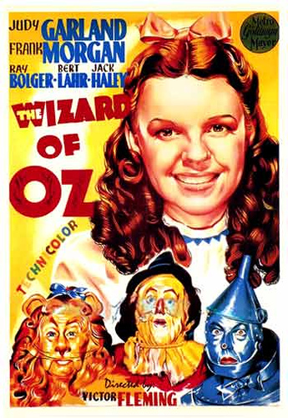

What’s the assignment?

You will choose a movie poster in order to analyze a visual argument. Movie posters are visual arguments to convince an audience to attend a movie. As such, they contain examples of ethos, pathos, and logos. Your job is to locate these arguments and determine whether they are affective. Three-fourths of the paper will be dedicated to finding and discussing these arguments. For the last part of the paper, you will examine whether these arguments were false representations of the movie. You will need to watch the movie to determine whether the advertisements were accurate. Make sure to be specific.

Steps to Success/ Questions to consider:

1. Pick a poster that has many different visual elements so you will have various angles to discuss in your paper.
2. Look at the design of the poster. Are some things emphasized more than others? For example are some things larger than others or bolded?
3. What text is on the poster? Does it make an argument? If so, how?
4. What images does the poster contain? What scenes are depicted? How do these scenes portray the movie? Does it communicate the genre?
5. Does the poster present an accurate account of the movie? Why or why not?

Don’t forget:

Include a works cited sheet with the film and poster.

Provide a picture of the poster you are analyzing in your paper.

**Visual Argument**