Writing as Inquiry 10803: Rhetoric of the Cinema

Contact Info:
Kassia (Jackson) Waggoner
Office hours: 10:30-12:00 T/TH
Reed 402
Kassia.d.jackson@tcu.edu
(Email is the best way to reach me as I frequently
check it throughout the day.)

Materials:
Lunsford, Andrea. Everyone’s an Author. NY: Norton & Co.,2013
Supplementary Texts found on PLS

Overview and Outcomes
Welcome to English 10803! This course is a writing workshop focused on writing as a kind of inquiry and the critical thinking that occurs while we write—not before we write. We’ll engage in processes of invention, critical reading, drafting, revision, and editing as we complete a range of writing tasks—from personal essays to argument essays—that include primary and secondary research. As we write, we will discuss everything from getting a first sentence on the page to revising a last draft. If we all do our part, together as a class we will have learned more about ourselves as writers, readers, and thinkers in order to write more effectively through college and beyond.
This course, like all courses at TCU, has outcomes explaining what students should achieve in the course. The outcomes listed here are the goals we are working toward, and the course was created to best help you meet those ends. By the end of ENGL 10803, students should demonstrate:
the ability to write in a range of genres, using appropriate rhetorical conventions, such as:
- Write multiple assignments in several genres, expanding their repertoire beyond predictable forms (e.g. the 5-paragraph essay)
- Create a text with a focus, thesis, or controlling idea, provide appropriate support for claims, use conventions of format and structure appropriate to the rhetorical situation, and recognize such in others’ text

Competency in reading, quoting, and citing sources as well as competency in balancing their own voices with secondary sources such as
- Find, evaluate, analyze, and synthesize appropriate primary and secondary sources to inform and situate one’s own claims.
- Critically read texts for main ideas and claims, for use of genre conventions, for rhetorical strategy, and for the position of the author.

the ability to employ flexible strategies for generating and revising their writing, such as:
- Write multiple revisions that might include substantive changes in ideas, structure, and supporting evidence, enabling students to experience writing as a recursive process.
- Practice writing assignments as a series of tasks (invention, drafting, revising, editing)

Competency in composing digital rhetoric in various forms.
- Creating a new media component to accompany each paper.
- Writing blogs that incorporate both written and visual elements of composition.

Note: Except for in class activities, all other assignments should be typed.

Major Assignments:

We’ll be producing four major and four minor assignments in the course totaling 20-30 pages of text. A new media component will be incorporated with each major paper. Before each assignment is due, you’ll receive a detailed assignment sheet. Honors students will be expected to complete 3 additional assignments detailed below.

Outside Event
At some point during the semester, you must attend one outside event pertaining to our subject matter of film: lecture, screening, workshop, etc. After attending the event, you will write a 300-500 word reflection of the experience describing what the event entailed, what you learned, and how it is applicable or shapes your opinion of the rhetoric of the cinema. In addition, you will be given 10-15 minutes of class time to present information about the event you attended and what you learned, so think about what the class might find especially interesting or enlightening about the topic in relation to our studies of rhetoric. You will be required to create a handout for the class advertising the event and including information you found important or relevant to our class.
Possible events:
Girls Studies Film Screenings (See the PDF on ecollege for further details)
Selma Screening (Feb 1)
TCU French Film Festival:
http://www.mola.tcu.edu/french_film_festival_S15.asp

Paper 1: Personal Narrative (Personal experience with film and genre)
You will write a 3-5 page paper depicting a scene from your life that could be made into a movie. A personal narrative allows you to reflect on a moment in your personal history. Many people say their life is like a movie. So, for this assignment, I encourage you to think of a time in your life that you think could have been made into a movie. An important question to consider would be what genre would this fall into?: Comedy, drama, romantic comedy, action, thriller, horror, sports film, etc. As you are telling the story, frame this scene as though it were going be to major motion picture. You’ll want to keep audiences interested in the plot. We will brainstorm for this assignment in class, and will look at some sample outlines.

New Media component: All movies need a movie poster. After writing about your personal narrative, you will create a poster that you feel is representative of this part of your life using a generator like the one found on movieposter.com. You will want to think about what visual elements best represent your life story. How will you entice viewers to visually come see your film? We will do most of this activity in class, but anything you do not finish in class, will be homework.

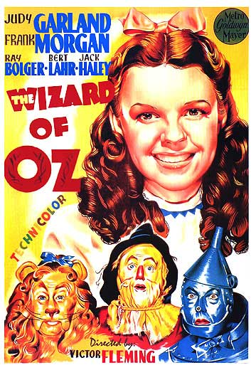
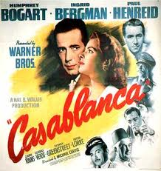
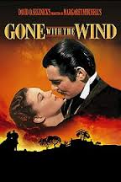

Outcomes for Portfolio 1:
- The ability to write in a range of genres, using appropriate rhetorical convention
Students will write in the narrative genre for this assignment.
- The ability to employ flexible strategies for generating and revising their writing
Students will participate in two writing workshops including in class revision activities throughout the unit
- Competency in composing digital rhetoric in various forms.
Students will create a movie poster using visual rhetoric to accompany this paper.
Students will also blog about how visual rhetoric produces a mini narrative. The blog incorporates both written and visual composition.

Paper 2: Discovery Essay
You will write a 5-7 page paper exploring a question about the movie industry. A Discovery essay allows you to explore a burning question you have yet to find the answers to. We will brainstorm a variety of questions in class pertaining to the movie industry. For example, are the Oscars inherently racist? Why are there less female directors than male directors? Why do certain genres never win an Oscar? How are films rated? These are but a few questions you might ask within this paper. Assignment sheet to follow.

New Media Component: For this essay, you will create an infographic to accompany your paper detailing your findings. We will have a new media workshop day in class in order to help us craft our images. Infographics can be easily made at sites like easel.ly.com or piktochart.com.

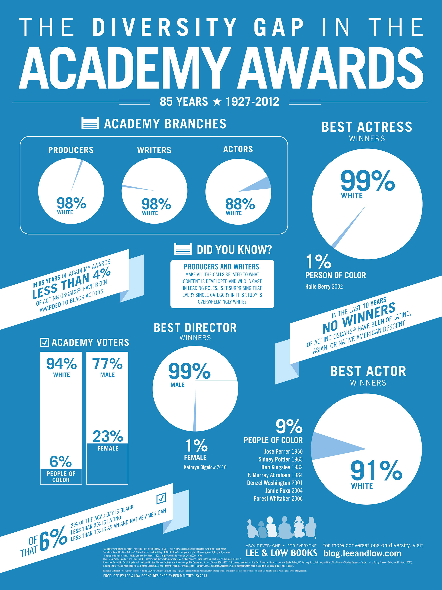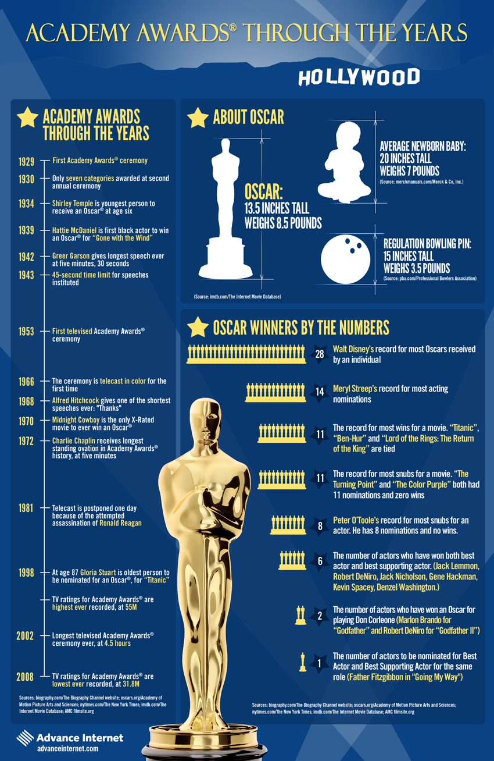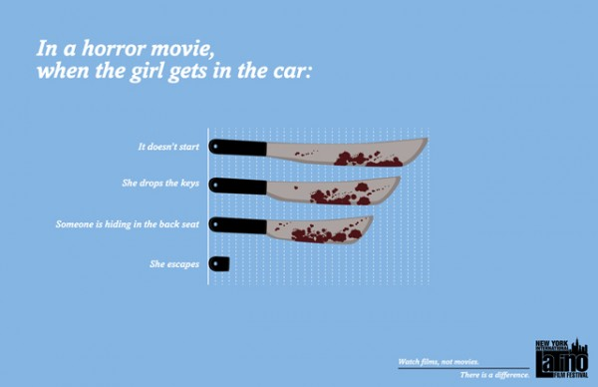

Documentary Reflection:
You will choose a documentary we have not watched or viewed clips from in class to further develop and reflect upon arguments made within the film industry. You will write a 500-700 word reflection addressing the following questions: What did you learn that you did not know? What surprised you? How did the documentary expand, counter, or make you rethink ideas or issues we’ve discussed or read about in class? If you were going to lead discussion about this documentary to the class, what are the things you would want the class to know, discuss or debate?

You will submit your reflection to the dropbox along with Portfolio 2, and it will be according to the following criteria:
· A. An excellent response. Describes the documentary clearly, and reflects in an insightful way on the link between the documentary and our class context. Is written in clear and sophisticated prose. Makes an original point that enhances our understanding of the issues at stake in thedocumentary. Connects the event to specific class readings or discussions. At least 500 words long.
· B. A good response. Describes the documentary, and reflects on the link between the documentary and our class context. Is written in clear prose. Makes a point that enhances our understanding of the issues at stake in the documentary. Connects the documentary to specific class readings. In other words, accomplishes all of the things a 9-10 point response accomplishes but differs in degree: the focus might require further narrowing, the point further refining, more evidence and analysis might need to be undertaken. Or perhaps the point is less original or helpful in considering issues at stake. At least 500 words long.
· C. An average response. Displays evidence that the writer has viewed a documentary and thought about it. Makes a point, but needs to focus more narrowly or present more evidence. May not connect the documentary to specific class readings. While grammatically correct, the writing style might need to be polished. Doesn’t make an original contribution, but does make an adequate one. Doesn’t show the rigor of thought of 8-10 point answers. At least 500 words long.
· D. A below average response. Does not display evidence that the reader has viewed a documentary. Does not offer reflection. Does not make a relevant or clear point. Rambles, is off-topic, does not contribute any new or useful understanding of the issues at stake. At least 500 words long.
· F. Does not meet the basic requirements of the assignment.
Potential Documentaries:
Tales From the Script
Life Itself
American Movie
A personal Journey with Martin Scorsese
Woody Alan: A documentary
Stanley Kubrick: A Life in Pictures
The Cutting Edge: The Magic of Movie Editing
Visions of Light: Cameramen and Women
Side by Side
Imaginary Witness
American Grindhouse
Copyright Criminals
(If you find another one you are interested in viewing, let me know, and we can discuss that option together.)

Outcomes for portfolio 2:

- The ability to write in a range of genres, using appropriate rhetorical convention
Students will write a discovery essay for this assignment.
- The ability to employ flexible strategies for generating and revising their writing
Students will participate in two writing workshops including in class revision activities throughout the unit.
- Competency in composing digital rhetoric in various forms.
Students will create an infographic to correspond with their findings.
Students will also blog about the representation test, one of the topics of controversy in the film industry, which will help them brainstorm for paper 2. The blog incorporates both written and visual composition.
- Competency in reading, quoting, and citing sources as well as competency in balancing their own voices with secondary sources.
Students will be asked to use at least five outside sources for this paper.

Paper 3: Profile Essay
You will write a 5-7 page paper profiling an actor or actress of your choice. A profile essay asks us to take a closer look at an individual. For this paper, you will be asked to profile an actor/actress, ultimately explaining why he or she would be a good fit for the movie you created in paper 1. Assignment sheet to follow.

New Media Component: Movies use a variety of marketing strategies to gain the public interest. Often they partner with other companies to do this. For example, Marvel partnered with Dr. Pepper to advertise their film on Dr. Pepper cans. Think about the ways you can use your actor or actress to promote the film for other companies. You will be asked to create 2 marketing items using various mediums, like photoshop, to promote your fictional movie and help establish the profile of your actor/actress that best fits this role. We will have a new media workshop day in class, and examples will be provided in class.

Outcomes for portfolio 3:
- The ability to write in a range of genres, using appropriate rhetorical convention
Students will write a profile essay for this assignment.
- The ability to employ flexible strategies for generating and revising their writing
Students will participate in two writing workshops including in class revision activities throughout the unit.
- Competency in composing digital rhetoric in various forms.
Students will create marketing items using their actor or actress as a spokesman.
Students will also blog about the example profiles found online, which will help them brainstorm for paper 3. The blog incorporates both written and visual composition.
- Competency in reading, quoting, and citing sources as well as competency in balancing their own voices with secondary sources.
Students will be asked to use at least five outside sources for this paper, with a special focus on digital scholarship.

Paper 4: Argument Essay
You will write a 5-7 page paper analyzing a movie and determining what type of argument that the movie is making. You will then argue whether or not you believe this movie was effective for the target demographic. An assignment sheet will follow.

New Media Component: Memes are visual arguments that normally satirize behavior or in some cases point out implied theses in films. For example, the Peter Pan meme below points out that Peter Pan could be viewed as a kidnapper despite the fact that he is not portrayed in this manner in the film. You will create a meme mini series of five based on a character or theme from the movie you analyzed in paper 4. Memes will be graded based on the common element, distinctive feature, connection to the film, and cohesion of argument. Examples will be shown in class, and we will have a new media workshop day to help us generate our memes. Memes can be easily made at sites like memegenerator.com.

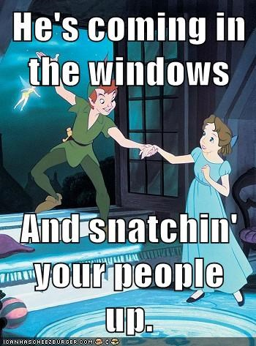

Outcomes for portfolio 4:

- The ability to write in a range of genres, using appropriate rhetorical convention
Students will write a profile essay for this assignment.
- The ability to employ flexible strategies for generating and revising their writing
Students will participate in two writing workshops including in class revision activities throughout the unit.
- Competency in composing digital rhetoric in various forms.
Students will create a meme mini series that supports the implied message of the film in visual form.
Students will also blog about a movie asking critical questions about the movie’s message and reviewing the film as a though they were a film critic. This corresponds to the book’s chapter on writing reviews, and will help them brainstorm for paper 4. The blog incorporates both written and visual composition.
- Competency in reading, quoting, and citing sources as well as competency in balancing their own voices with secondary sources.
Students will be asked to use at least five outside sources for this paper.

Blogs: Over the course of the semester, we will be blogging a total of four times over varying topics pertaining to film. These blogs will give you a chance to show reading comprehension, explore new topics or brainstorm for upcoming papers, respond to current conversations about film, and hone your new media literacy skills. Blog prompts will be found on PLS under the blog tab. Each blog will be worth 3% of your grade.

Blog #1: You will watch a movie of your choice and compare it to its movie poster. Does the movie poster do a good job communicating the main idea of the film? Is it misleading in any way about the genre, the subject, or the characters? Is it successful in enticing you to see the film prior to the viewing? These are but a few questions we will discuss in class, and you will explore for this prompt. Don’t forget to respond to one of your peer’s posts.

Blog #2: You will analyze a movie of your choice according to the Rep test found on doc sharing. Score it accordingly and then write about your findings. Were you surprised by the results; why or why not? Explain why the movie received the score it did by pointing us to specific scenes in the film. Overall, is this rating system fair? What do you think it reveals about the movie you watched? The characters? The director? The production company? Don’t forget to respond to one of your peer’s evaluations. The blog is designed to help you you see the complexity of several current criticisms of films and help you brainstorm potential questions that may turn into controlling ideas for paper 2.

Blog #3: You will look up an interview of your favorite actor or actress. How do you think he or she wanted to be portrayed to the audience? Does this differ from how you previously viewed him or her? How does the interviewer help shape your perception of the actor or actress? What is the main take-away of the interview? In other words, what is the main idea/ thesis? We will watch a few examples in class to practice this analysis. Don’t forget to comment on a peer’s post.

Blog #4: We will be taking a closer look at children’s movies and their messages. While these messages may seem obvious to us, they are not always obvious to the children they target. Most messages in children’s movies tend to be cliché, so we will problematize these. We will watch several clips and discuss the overt and implied messages, and then you will locate a children’s movie you believe to have an implied thesis. You will identify the message and discuss how the movie argues/presents the message to the public. Who was the intended audience? Was the argument effective? Don’t forget to comment on a peer’s post.

Blog site: studentskeepitreel@blogspot.com

Final Project:
For the final project, students will create a 2:30-3:00 min movie trailer using imovie or moviemaker. Students will be given time in the NMWS to work on their trailer with experts. An assignment sheet will be provided in class as well as a resource guide. We will present these trailers to the class on the day of the final.

Pitch:
You will write a 3-5 page paper pitching this movie to the studio of your choice. You’ll want to consider the following questions: 1.) How or why is this movie a good fit for the studio? : Is this a genre they have experience with? Does it fit in their wheelhouse of prior films? How is it distinct from those it has already produced? In other words how does this film help build and establish the studio’s ethos? 2.) How is this movie going to make the studio money? Perhaps the actresses or actors you have casted will be a big draw. Maybe it’s a genre that is appealing to a wide range of audiences. Perhaps the release date will impact attendance, and so on. 3.) How will this benefit the studio beyond the revenue? Do you anticipate that this film will win any type of awards: Oscars, Golden Globe, MTV, People’s Choice, Critic’s Choice, etc.? Be sure to explain your rationale. You will submit this assignment to the dropbox along with your trailer.

Revisions: You have the option of revising two of the four required papers for this course. Revisions may be turned in at any time after the original scores are received, but the final day for revisions is demarcated on the syllabus. If you did not attend the writing workshop for this paper, you are not eligible to rewrite it. To turn in a revision, you must annotate all your corrections, explaining why you are choosing to change or fix a section of your paper using the comment feature on either word or pages. You are also required to meet with me once before you turn in a revision so we can discuss your plan of action, and your original rubric. If you fail to do either of the above, the revision will not be graded.

Course Policies

Attendance
Improvement in writing is a complex process that requires lots of practice and feedback from readers. Regular attendance is necessary to your success in this course. It is a Composition Program policy that in writing workshop courses, only official university absences are excused. Students representing TCU in a university-mandated activity that requires missing class should provide official documentation of schedules and turn in work in advance. Three weeks of unexcused absences (six in a MW/TR course, nine in a MWF course) constitute grounds for failure of the course. Absences due to illness, sleeping, and long weekends are NOT excused--they all count toward the three weeks' absences limit. Since illness is likely at some point during the semester, students are urged to save their unexcused absences for times when you are too sick to come to class. Absences under the three-week maximum can still affect your grade adversely. TR/MW: After two unexcused absences, half a letter grade will be subtracted from your final grade for each additional absence (i.e.: if you are at a B and miss three classes, your grade would be a B-, with four, a C+, with 5, a C, etc). MWF: After three unexcused absences, each additional absence will cause your final grade to drop half a letter grade (i.e.: if you are at a B and miss four classes, your grade would be a B-, with five, a C+, with six, a C, etc.] Students whose absences are due to circumstances beyond their control may appeal this policy by scheduling a meeting with the Director of Composition. Generally, the Director of Composition does not excuse additional absences without documentation. To do well in this course, you must come to class.
Portfolio 1 | Paper (10%) | Movie Poster (5%) | Total:  15%
Portfolio 2 | Paper (10%)  Documentary reflection (5%) | Infographic (5%) | 20%
Portfolio 3 | Paper (15%) | Marketing items (5%) | 20%
Portfolio 4 | Paper (15%) | memes (5%) | 20%
Final Project | Movie Trailer (4%) | Pitch (4%) | 8%
Blogging | 12% |  | 12%
Outside Event |  |  | (5%)
A | 4.00
A- | 3.67
B+ | 3.33
B | 3.00
B- | 2.67
C+ | 2.33
C | 2.00
C- | 1.67
D+ | 1.33
D | 1.00
D- | 0.67
F | 0.00
You will receive a letter grade score on your papers and projects, which is converted to the 4.0 scale as shown in the above chart. Because I grade on 4.0 scale, I do not use gradebook. So, I have included the 4.0 scale above, as well as the weights so that you can calculate your own grade as we go. If you ever have questions about a grade, please come and meet with me after class or in my office.

Late Work: I do not accept late work, so make sure you are responsible and turn your work in on time.

Pearson Learning Studio Class Website
We have a course website we’ll use for various activities throughout the course: some required course readings will be there; discussion threads (when applicable); sharing resources on the webliography; accessing handouts for the course; and sometimes submitting course assignments to the course dropbox. However: most major assignments (rhetorical responses, essay drafts, etc.), I’ll be collecting via hard copy (as well as sometimes having you also submit the assignment to Pearson LearningStudio).
TCU Disability Statement (verbatim from TCU catalog)
Texas Christian University complies with the Americans with Disabilities Act and Section 504 of the Rehabilitation Act of 1973 regarding students with disabilities. Eligible students seeking accommodations should contact the Coordinator of Student Disabilities Services in the Center for Academic Services located in Sadler Hall, 11. Accommodations are not retroactive, therefore, students should contact the Coordinator as soon as possible in the term for which they are seeking accommodations. Further information can be obtained from the Center for Academic Services, TCU Box 297710, Fort Worth, TX 76129, or at (817) 257-7486.
Adequate time must be allowed to arrange accommodations and accommodations are not retroactive; therefore, students should contact the Coordinator as soon as possible in the academic term for which they are seeking accommodations. Each eligible student is responsible for presenting relevant, verifiable, professional documentation and/or assessment reports to the Coordinator. Guidelines for documentation may be found at http://www.acs.tcu.edu/disability_documentation.asp

Students with emergency medical information or needing special arrangements in case a building must be evacuated should discuss this information with their instructor/professor as soon as possible.

Academic Misconduct (Sec. 3.4 from the Student Handbook):
Any act that violates the academic integrity of the institution is considered academic misconduct. The procedures used to resolve suspected acts of academic misconduct are available in the office of Academic Deans and the Office of Campus Life. Specific examples include but are not limited to:
- Cheating: Copying from another student’s test paper, laboratory report, other report, or computer files and listings; Using, during any academic exercise, material and/or devices not authorized by the person in charge of the test; Collaborating with or seeking aid from another student during a test or laboratory without permission; Knowingly using, buying, selling, stealing, transporting, or soliciting in its entirety or in part, the contents of a test or other assignment unauthorized for release; Substituting for another student or permitting another student to substitute for oneself;
- Plagiarism: The appropriation, theft, purchase or obtaining by any means another’s work, and the unacknowledged submission or incorporation of that work as one’s own offered for credit. Appropriation includes the quoting or paraphrasing of another’s work without giving credit therefore.
- Collusion: The unauthorized collaboration with another in preparing work offered for credit.

TCU Resources
New Media Writing Studio. | Scharbauer 2003 | www.newmedia.tcu.edu | newmedia@tcu.edu | 817‐257‐5194
The New Media Writing Studio (NMWS) is available to assist students with audio, video, multimedia, and web design projects. The Studio serves as an open lab for use by students during posted hours and has both PC and Mac computers outfitted with a range of design software. A variety of equipment is available for checkout to students whose teachers have contacted the Studio in advance. See their website for more information and a schedule of open hours.

Center for Writing. | Reed 419 | www.wrt.tcu.edu | 817‐257‐7221
The William L. Adams Center for Writing is an instructional service with the mission of helping members of theTCU community improve their writing. Consultants offer feedback on writing projects to students, staff, and faculty from all academic disciplines. Consultants work with writers on projects such as essays, theses, dissertations, books, letters of application, articles, and other creative, personal, and academic projects. In addition to serving as a friendly audience, consultants address any issue a writer would like to discuss, though consultations often focus on topic generation, organization of ideas, style, clarity, and documentation. Go to their website to see their hours and make an appointment.

IC Computer Lab | Mary Couts Burnett Library | www.ic.tcu.edu
The Information Commons computer lab is an open use lab available to all TCU students. Access is first come, first served, with the exception of four multimedia stations that can be reserved for use at specific times if requested. Assistance is available from the Information Commons desk staff during all open hours, with additional support from either the full‐time Computer Services Librarian or the full‐time Computer Lab Assistant during most hours.

TCU Computer Help Desk | Mary Couts Burnett Library (first floor) | www.help.tcu.edu | 817‐257‐5855

T/TH class Daily Schedule

The syllabus is subject to change. If such a change occurs, I will notify you in class or through email.

Week 1
T 1-13 Introduction to the syllabus/ blog sign up and intro/ Writing History
Homework: Ch. 8 Writing a Narrative
& Color by Giannetti (doc sharing)

TH 1-15 Assign and do invention activity for Essay 1 &
Visual Argument Analysis activity for blog 1
Homework: Ch. 1 Thinking Rhetorically

Week 2
T 1-20 Discussion of Movie Posters
Homework: Ch. 3 Writing Processes

TH 1-22 Storyboarding/ Creating a Scene
Author’s notes, discussion about drafting
Blog 1 Due
Week 3
T 1-27 Conferences

TH 1-29 Reading Table: draft Workshop
Week 4
T 2-3 Blog 2 breakdown Explanation of Rep Test
Sign up for film

TH 2-5 New Media workshop/ Assign paper 2
Homework: Ch. 9 Writing Analytically
Portfolio 1 Due by midnight to the dropbox
Week 5
T 2-10 Discussion of paper 2: controversial issues in film: Rating System
Homework: “Unmasking the Academy: Oscar voters overwhelmingly white, male” Click on the hyperlink or go to the webliography
Dual Entry Sources (form found on doc sharing)

TH 2-12 controversial issues in film: Are the Oscars Racist? / Plagiarism in the movies
Homework: “Age Gap between Men and Women in Movies” (webliography)
Week 6
T 2-17 Misrepresentation
Homework: A critique of Misrepresentation (webliography)

TH 2-19 Misrepresentation
Midterm reflection
Blog 2 Due by midnight
Week 7
T 2-24 Essay 3 assigned and discussed /Paper 2 Reading Table

TH 2-26 New Media Workshop: Infographics
Homework: The American Star System, Casting, and Styles of Acting by Gianetti (doc sharing)/ Watch Film clips of interviews with directors and actors found on webliography

Week 8
T 3-3 Discuss primary and secondary research/ Ethos of actors and actresses
Homework: Ch. 27 From Tweets to Reports
Portfolio 2 due to the dropbox by midnight

TH 3-5 product placement in film
Blog 3 due to the dropbox by midnight

Week 9
T 3-10 Spring Break

TH 3-12 Spring Break
Week 10
T 3-17 Paper 3 Reading Table

TH 3-19 New Media Workshop: Creating your Meme miniseries
Homework: Ch. 13 Analyzing Arguments
Week 11
T 3-24 Implied Thesis in Film Disney and Beyond /Discuss Blog 4
Homework: Michael Smith’s “Skewed Views of Animal Rights: Blame Disney!” from The Herald (webliography) and Disney Animal Rights Agenda (webliography)
Portfolio 3 due to the dropbox by midnight

TH 3-26 Assign and Discuss paper 4/ sign up for movies
Homework: supplemental reading from Understanding Movies, “Ideology” (doc sharing)
Week 12
T 3-31 Film Analysis Practice: Begin Fern Gully & worksheet
Homework: Ch. 11 Writing a Review

TH 4-2 Film Analysis Practice: Finish Fern Gully/ group activity
Homework: George Bush and Pro War Movies (webliography) and “Movies with a Message (webliography) and Korea declares Movie an Act of War (webliography)
Blog 4 Due
Week 13
T 4-7 Cultural Impact of Film

TH 4-9 Paper 4 Reading Table
Week 14
T 4-14 New Media Workshop: Memes

TH 4-16 transition to Final Project: analyzing movie trailers
Week 15
T4-21 Discussion of genre bends vs. mash-ups
Portfolio 4 due

TH 4-23 Final Project Workshop: Storyboarding
Week 16
T 4-28 Final Project Workshop: Studio, clips, and rating

TH 4-30 Final Project Workshop: putting it all together
Week 17
Finals: Presentation of Trailer/ Awards
TBA

